BUS TRANSPORT MANAGEMENT
@CREATIVITY THINK (9483175986/7019689991)

ABSTRACT:
Bus Transport Management is a DashboardApp designed to streamline bus route management, ticket bookings, and attendance tracking for schools, travel firms, and public transport services. Users can search routes, book tickets, make payments, check schedules, view history, and mark attendance. Administrators manage routes, assign buses and drivers, handle bookings, send notifications, and monitor analytics dashboards. Built with Django and Django Rest Framework for backend services and React with Leaflet and Recharts for frontend visualization, the system ensures efficient transport operations, real-time monitoring, and data-driven decision-making for both users and administrators..

INTRODUCTION OF THE PROJECT:
Transport operations, especially in schools, travel firms, and public transit systems, require organized route planning, booking management, and attendance monitoring. Bus Transport Management provides a centralized dashboard where users can search routes, book tickets, make payments, and track schedules. Administrators can add or edit routes, assign buses and drivers, manage bookings, send notifications, and analyze transport data. Using Django and Django Rest Framework for backend logic and React with Leaflet and Recharts for frontend dashboards, this platform enhances operational efficiency, improves communication, and provides actionable analytics for administrators..

PROJECT OBJECTIVES:

• Manage bus routes and schedules efficiently
• Facilitate ticket booking and payment processing
• Enable users to track attendance and view history
• Assign buses and drivers for smooth operations
• Send notifications to users regarding updates or delays
• Provide administrators with analytical dashboards
• Reduce operational errors and improve efficiency

PROBLEM OF THE STATEMENT:
Managing bus transport operations manually can lead to scheduling conflicts, missed trips, inefficient route planning, and lack of attendance tracking. Users face difficulties in booking tickets, checking schedules, and monitoring travel history. Bus Transport Management solves these issues by providing a web-based dashboard where users can search routes, book tickets, make payments, and track attendance, while administrators efficiently manage routes, buses, drivers, bookings, and analytics. This ensures organized transport operations, timely updates, and data-driven decision-making..

MOTIVATION OF THE PROJECT:
• Streamline bus transport operations for schools and firms
• Facilitate easy route search, booking, and payment for users
• Enable administrators to manage buses, drivers, and schedules
• Provide real-time monitoring and notifications for timely updates
• Offer dashboards with analytics for operational efficiency

BLOCK DAIGRAM OF PROJECT:

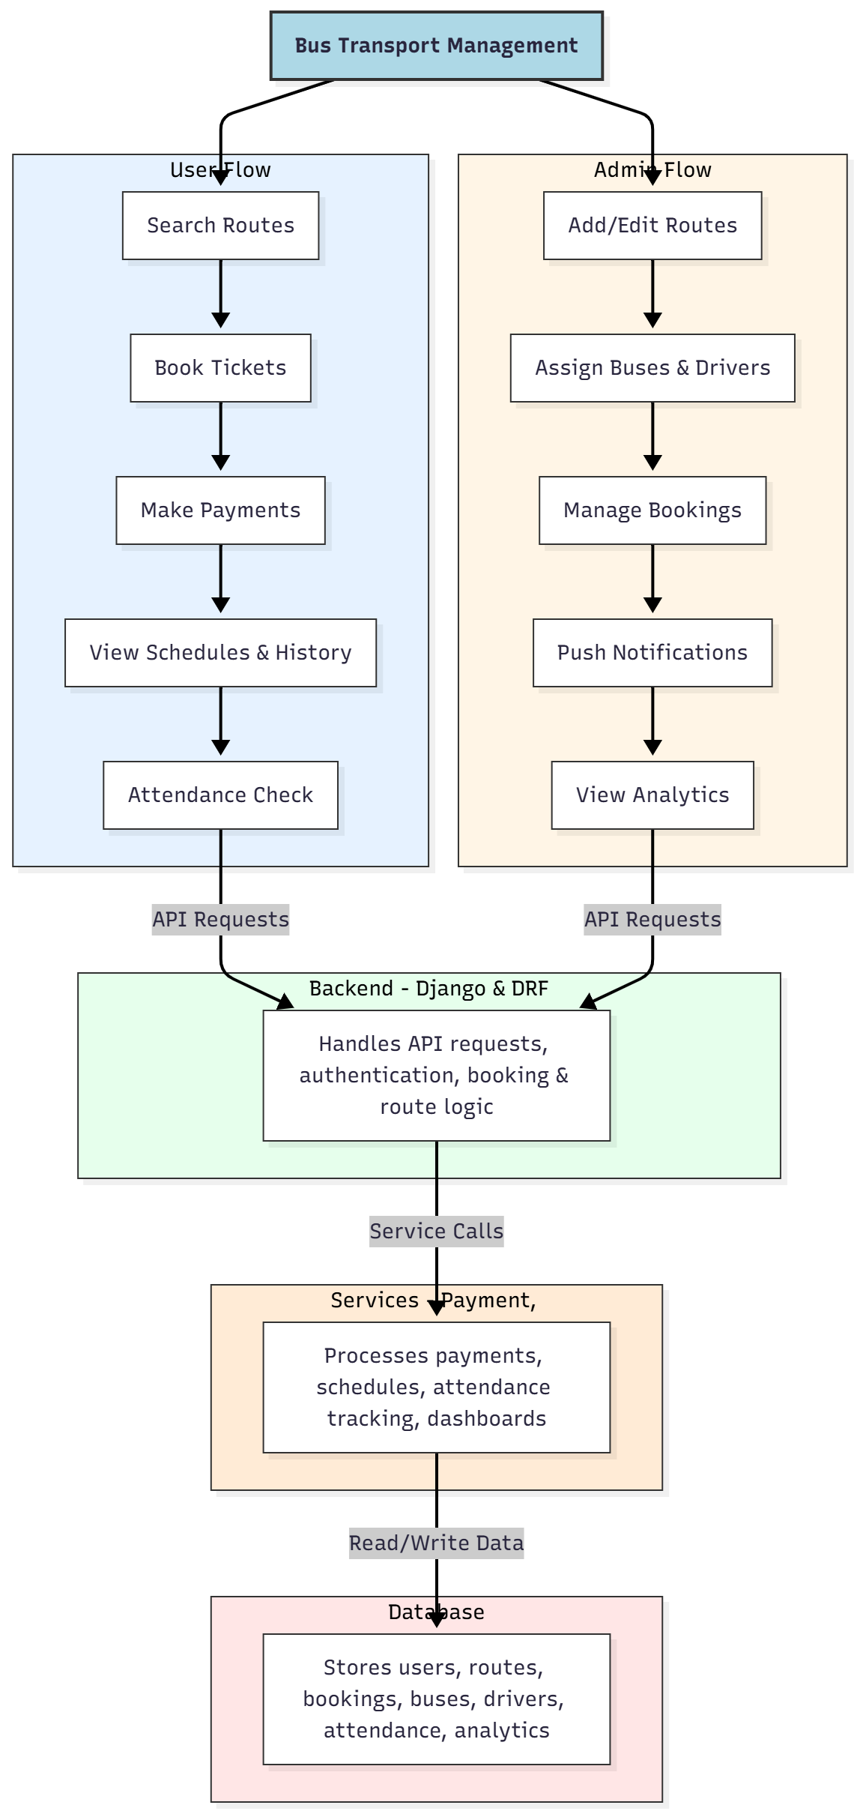

WORKING OF THE PROJECT:
Users search available bus routes, book tickets, make payments, view schedules and travel history, and mark attendance. The backend handles API requests, authentication, booking logic, and route management. Services manage payments, notifications, schedule updates, attendance tracking, and dashboard analytics. Administrators add or edit routes, assign buses and drivers, manage bookings, send notifications, and monitor analytics dashboards. This system provides real-time transport management, efficient booking, and comprehensive operational oversight for both users and administrators..

SOFTWARE REQUIREMENT:
- Backend:
  - Python 3.x
  - Django
  - Django REST Framework
  - SQLite/PostgreSQL
- Frontend:
  - Node.js and npm
  - React.js
  - Axios
- Development Tools:
  - Visual Studio Code
  - Postman (for testing APIs)
  - Git/GitHub (for version control)
- Server/Deployment (Optional):
  - Gunicorn, Nginx, or Heroku/AWS for hosting

ADVANTAGES OF THE PROJECT:

• Centralized bus route and schedule management
• Streamlined ticket booking and payment processing
• Real-time attendance tracking
• Administrator dashboards for analytics and operations
• Notifications for timely updates
• Reduces operational errors and mismanagement
• Supports schools, travel firms, and public transport services
• Improves user convenience and efficiency

APPLICATIONS OF THE PROJECT:
• School transport management
• Travel agency route and booking management
• Public bus transportation systems
• Attendance tracking for daily routes
• Payment processing for bus services
• Notifications and schedule alerts
• Analytics dashboards for operational decisions
• Centralized administration of buses and drivers

REFERENCES:

- Django REST Framework Documentation — Django Software Foundation. Django Documentation. Available: https://docs.djangoproject.com/
- Django REST Framework. DRF Documentation. Available: https://www.django-rest-framework.org/
- React. React Official Documentation. Available: https://reactjs.org/docs/getting-started.html
- Redux. Redux Documentation. Available: https://redux.js.org/introduction/getting-started
- PostgreSQL Global Development Group. PostgreSQL Documentation. Available: https://www.postgresql.org/docs/
- MySQL. MySQL Reference Manual. Available: https://dev.mysql.com/doc/
- Git. Git Documentation. Available: https://git-scm.com/doc
- Node.js. Node.js Documentation. Available: https://nodejs.org/en/docs/
- Axios. Axios Documentation. Available: https://axios-http.com/docs/intro
- Socket.io Documentation – https://socket.io/docs/

